**LEBANESE AMERICAN UNIVERSITY**

**USAID – HIGHER EDUCATION SCHOLARSHIP PROGRAM**

**HES - Volunteering Program Verification Form**

This form is to be used to document volunteering hours. If a student volunteers for multiple organizations, a separate form must be used for each organization. **This form must be turned in by the 28th of each month, the latest.**

I certify that the scholar Lina Ghazi Bekai completed a total of 5 hours of service at InnovaThrive.

The hours were completed hours as per the below:

Hours # 0 (date) _2/12 – 6/12_ (initials of supervisor) __A.K.___

Hours # 0 (date) _9/12 – 13/12_ (initials of supervisor) __A.K.___

Hours # 0 date) _16/12 – 20/12 (initials of supervisor) __A.K.___

Hours # 5 date) _23/12 - 27/12 (initials of supervisor) __A.K.___

Brief description of the activities the scholar performed or participated in:

I researched AI's role in climate-resilient agriculture, focusing on tools like climate modeling, pest detection, and soil monitoring. I explored benefits like higher yields, challenges like costs for low-income farmers, and future research areas such as climate impact prediction and cooperative farming.

Written feedback about the scholar’s performance:

Lina demonstrated a solid understanding of AI in agriculture, using her analytical and creative skills to address challenges in climate resilience. Her exploration of practical tools showed an aptitude for bridging technology and sustainability.

Please rate the overall performance of the scholar at your organization:

|  |  |  |  |
| --- | --- | --- | --- |
|  | Mastery (5) | Proficient (3) | Emerging (1) |
| **Problem solver** | X |  |  |
| **Engaged & Committed** | X |  |  |
| **Open-minded & multicultural** | X |  |  |

Signature

& stamp

__________________________

_

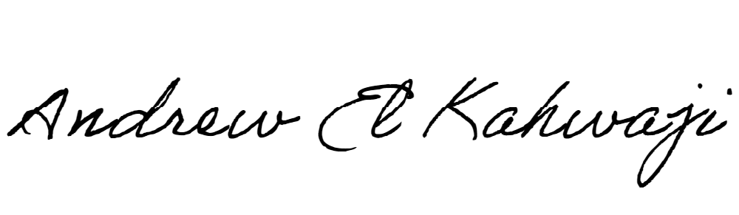

Printed Name _Andrew El Kahwaji_

Date __26/12/2024___

Email __andrew.lifesculptor.coo@gmail.com __

Phone __+961 71 914 378__